**Chemistry 386J** Name: _______________________________

**Anslyn**

**December 3, 2011**

**Exam 3**

1. __________ ( 6 points)
2. __________ ( 8 points)
3. __________ ( 6 points)
4. __________ ( 12 points)
5. __________ ( 10 points)
6. __________ ( 12 points)
7. __________ ( 15 points)
8. __________ ( 10 points)
9. __________ ( 14 points)
10. __________ ( 8 points)
11. __________ ( 6 points)
12. __________ ( 8 points)
13. __________ ( 10 points)
14. __________ ( 10 points)

Total. _____________ ( 135 points)

1. Label the Jablonski diagram below. (6 points)

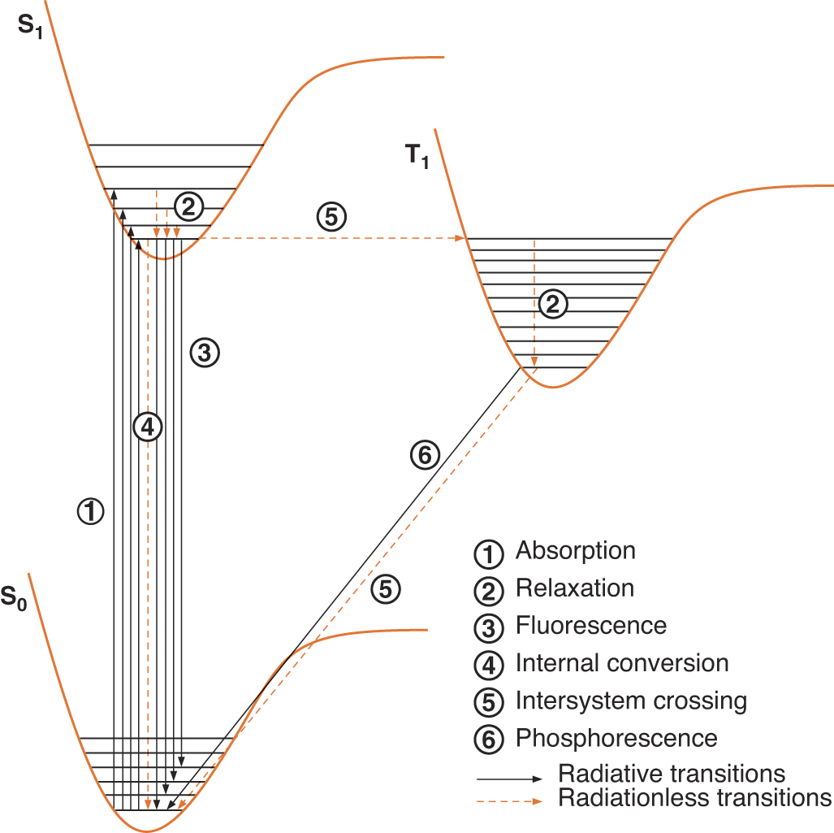

|  |  |
| --- | --- |
|  | Process Name |
| 1 |  |
| 2 |  |
| 3 |  |
| 4 |  |
| 5 |  |
| 6 |  |

2. Because a polar solvent increases the rate of an SN1 reaction, the addition of salts such as NaCl to increase the polarity of the medium will often also increase an SN1 reaction. A relationship such as that given in the following equation (A) can often be found, where the rate constant for an SN1 reaction has a *kobs* equal to the *k* without salt, and then a linearly additive factor related to salt concentration (A). Such a relationship is seen in the top line (B) given in the figure below for the SN1 reaction shown (C). This line shows the rate constant for the loss of stereochemistry at the stereocenter of the leaving group of the reactant upon addition of LiClO4. This rate constant directly reflects the rate of carbocation formation, rather than product. The bottom line of (B) shows a very different shape for product formation as LiClO4 is added. [Things to keep in mind: perchlorate (ClO4-) is completely non-nucleophilic, and think about the mechanism for SN1 as presented in class (D)]. (8 points)

(A) *kobs* = *k1* ( 1 + *b* [salt] ) (C)

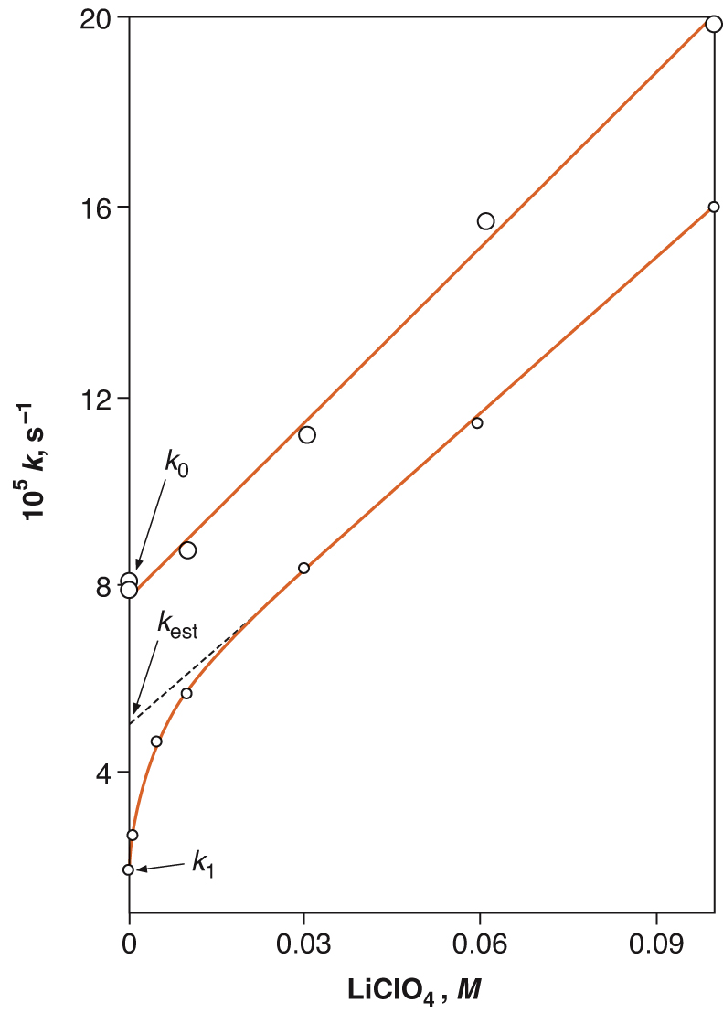

(B)

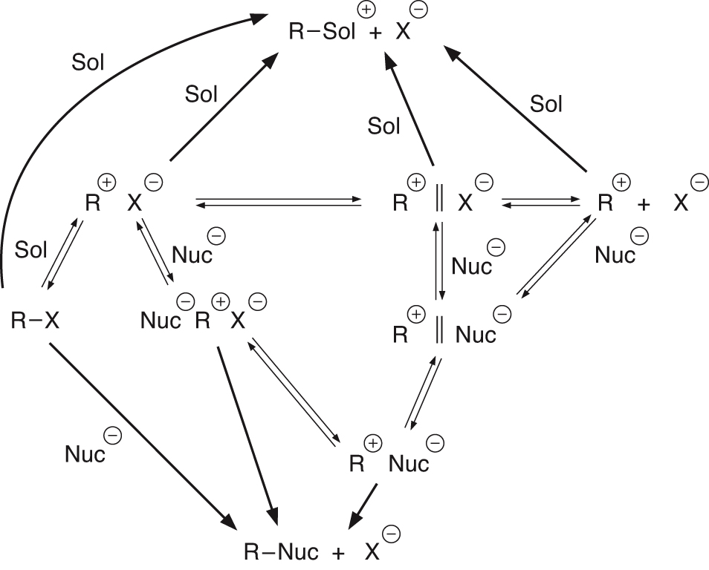

(D)

1. In a few sentences, tell us how the very rapid increase in the SN1 product formation can be understood at low concentration?
2. In a few sentences, tell us why does the dependence of product formation ultimately parallel the rate constant for racemization?

3. Your TA Leo works on a collaboration with Professor Scott Miller at Yale University to rapidly determine the enantiomeric excess of an asymmetric Baeyer-Villiger reaction of various cyclobutanones. Draw the mechanism for this acid-catalyzed Baeyer-Villiger oxidation reaction, making sure to show all participating lone pairs, applicable formal charges, and required arrow pushing to indicate the flow of electrons. (6 points)



4. Please predict the major product of the following elimination reactions. (12 points)

 a.



b.

 c.

 d.

 e.

 f.

5. This question refers to cyanide substitution of two different bicyclo[3.3.1]nonane compounds. The reactions are shown below. (10 points)



1. When the substitution noted in A) is carried out, we see no dependence of the rate on the concentration of the nucleophile. Additionally, we see that the stereochemistry of the addition is scrambled. Draw a mechanism that is consistent with these experimental observations.
2. When the substitution noted in B) is carried out, we also see no dependence of the rate on the concentration of the nucleophile. In this case we see that substitution leads to a retention of stereochemistry. Draw the intermediate you would expect for this reaction.
3. This question refers to the intermediate that you have drawn for the mechanisms in parts a and b. Considering the structure of these intermediates, how can you rationalize the stereochemical outcome of these reactions?
4. One of these reactions proceeds significantly faster than the other. Which reaction goes faster? Why?

6. For the reactions below, draw the HOMO of the 4π-system and the LUMO for the 2π-system for a 4+2 cycloaddition. Be sure to show the relative sizes of the coefficients for each orbital to reflect differences from butadiene and ethylene. Next, predict the major product of the reaction. Make sure to show the correct regiochemistry of the product, as well as the relation of the substituents on the product that arise from the diene (*cis*- or *trans*-) if applicable. (12 points)

 a.

 b.

7. The reaction of ethylene and an azide (termed the Click reaction) is a [4+2] cycloaddition and gives rise to a five membered ring as pictured below. (15 points)



The following parts of this question will assist you in drawing an Orbital Correlation Diagram for this reaction. Assume suprafacial attack for the corresponding questions.

1. Show another resonance structure for the azide starting material.



1. Show arrow pushing for the click reaction.
2. For the orbital correlation diagram that you will draw on the next page, find a symmetry element that is present for suprafacial attack for both π-systems (ignore the R groups).
3. Draw the orbitals of the reactants and products that are changing during the reaction, with the reactant orbitals on the left and the product orbitals on the right. (Hint: there should be 5 orbitals on each side.)
4. Populate the orbitals with the appropriate number of electrons and assign symmetry to each orbital drawn.
5. Is this reaction allowed or forbidden?
6. Briefly explain how you reached your conclusion in part f.

8. Neighboring groups that can stabilize a developing carbenium ion will assist an SN1 mechanism and other mechanisms involving carbocation intermediates. There are seven ways we discussed in lecture that can stabilize carbenium ions. List any five of the seven ways, and draw an orbital picture/cartoon to depict each way you list. (10 points)

|  |  |  |
| --- | --- | --- |
| **Number** | **Stabilization** | **Picture** |
| 1 |  |  |
| 2 |  |  |
| 3 |  |  |
| 4 |  |  |
| 5 |  |  |

9. For the following elimination reaction, fill in the corners on the More-O’Ferrall-Jencks plot. (14 points)

1. Show what happens to the E2 transition state when the leaving group is changed from I to F, label this point as “T.S.1”.
2. How does this affect leaving group departure?
3. How does this affect the extent of deprotonation?
4. As the leaving group is changed from I to F, the  value in the corresponding Hammett plot changes from 2.07 to 3.12. Explain this result, by relating back to your results obtained with the More-O’Ferrall-Jencks plot.
5. If the reactant is changed to put an acetyl group at the benzyl position,

(pictured at the right) show on the above plot what happens to E2

transition state and label this point as “T.S.2”.



1. How does this affect leaving group departure?
2. How does this affect extent of deprotonation?
3. With the acetyl group, the mechanism might change to E1CB. If the mechanism were to convert to E1CB, write a rate law for this elimination mechanism. Use the steady state approximation if you like.
$$\frac{dP}{dt}=$$

4. What experimental parameter actually controls the reaction rate as concluded by your rate law in part h, if the second step is rate determining?

10. This question pertains to research conducted by your TA Michelle. The following molecule was first synthesized by Gregorgio Weber, one of the pioneers of biofluorescence chemistry. It is called PRODAN, for short, and is commonly used in protein chemistry to probe the hydrophobic pockets of proteins. (8 points)



1. The following is an overlay of the absorption spectra (max = 360 nm) and fluorescence emission spectra (max = 520 nm) of PRODAN in various solvents. What is the term given to the phenomenon which is seen when the max of the shortest emission wavelength is found to the right of the max of the longest absorbance band?

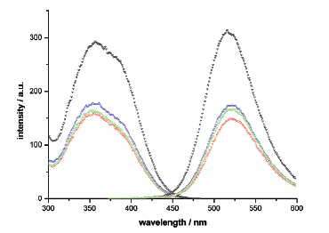

1. Why does this phenomenon occur?

The following spectra are a result of the titration of protein into a solution of PRODAN in water. The spectra indicate the binding of PRODAN into the hydrophobic pocket of the protein, as PRODAN moves from a hydrophilic environment (the solvent) to a hydrophobic environment (protein binding pocket).

1. The excited state of PRODAN is thought to resemble a charged species. Using this knowledge, explain the hypsochromic shift (blue shift) seen upon PRODAN binding to the protein.



11. The addition of HCl to 1-phenylpropyne in acetic acid gives predominately the syn product with the regiochemistry shown below. (6 points)



1. What does the regiochemistry indicate about the mechanism?
2. What does syn stereochemistry addition indicate about the mechanism?

12. Choose between the following options to maximize the probability of an SN2 mechanism and to minimize the probability of an SN1 mechanism. Briefly explain each of your choices. (For part c, =dielectric constant). (8 points)

1. Reactant:
2. Nucleophile:



1. Solvent:

(= 39) (= 33)

1. Concentration of Nucleophile:

13. For each reaction (1) classify the [x#y+x#y] process which occurs, where x=  or , #= # of electrons, and y= s or a (for example [2s + 2a]), and (2) using the Woodward-Hoffman Rules determine if the reaction is allowed or forbidden as drawn. (10 points)

1. 
2. 

14. Using Frontier Molecular Orbital Theory, show with a picture whether the allowed reaction will be conrotatory or disrotatory and then circle the corresponding stereochemistry which will arise. (10 points)

1. 



1. Are these reactions stereoselective?
2. Are these reactions stereospecific?