**Chemistry 386J** Name: _______________________________

**Anslyn**

**November 5, 2011**

**Exam 2**

1. __________ (12 points)
2. __________ (8 points)
3. __________ (12 points)
4. __________ (12 points)
5. __________ (8 points)
6. __________ (12 points)
7. __________ (6 points)
8. __________ (10 points)
9. __________ (7 points)
10. __________ (9 points)
11. __________ (12 points)
12. __________ (10 points)
13. __________ (6 points)

Total. _____________ (124 points)

1. (12 points)

a) The p*K*a of an alkyl guanidinium group is 13, while a phenylguanidinium is around

10, and an acylguanidinium is around 7. Give an explanation for this trend.



b) What roughly is the p*K*a value of the nitrogen-based cation shown below in water?



c) i. Below we show a plot of both a bis-acylguanidinium receptor (middle structure shown below) and lutidinium titrated with the base DBU in the solvent acetonitrile. By inspection of this graph, estimate the first and second p*K*a values of the receptor and the p*K*a of the lutidinium.

pH

_________ 1st pKa of receptor

_________ 2nd pKa of receptor

_________ pKa of Lutidinium

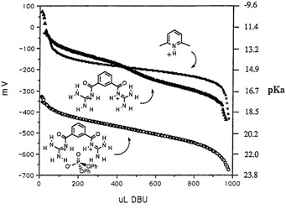

ii. Will lutidine (shown below) deprotonate the receptor in acetonitrile?



iii. Why are the p*K*a values for both the bis-acylguanidinium receptor and lutidinium

higher in acetonitrile relative to water?

iv. Why do the p*K*a values for the receptor get even higher when phosphate is

bound (see the figure)?

2. (8 points) During the SN1 solvolysis of isopropyl bromide in water, we see the following isotope effect:



1. Explain the origin of this isotope effect by explaining what vibrational mode is

changing in the rate determining step of this reaction.

We also observe the following isotope effect:



1. During the SN1 rate-determining step, explain how the methyl groups are involved in facilitating the reaction?
2. Explain the origin of this isotope effect by explaining what vibrational mode is

changing.

3. (12 points) The mechanism for proton transfer in porphyrins has received much attention. It is thought that the mechanism proceeds in two steps, proceeding through the cis-isomer (**2**). This structure, however, has never been experimentally observed because it is too high in energy. Much of the insight garnered on this process has come from NMR studies of hydrogen (H), deuterium (D), and tritium (T) at the circled positions. The scheme for this process is shown below.



1. Below you are given a reaction coordinate axis for the isomerization. Please draw a diagram showing the relative energies of the degenerate *trans* isomers **1** and **3**, as well as the *cis* isomer **2**. Make sure you label the isomers on your coordinate diagram.

Reaction coordinate

Energy

1. Indicate on your diagram the zero-point vibrational energy levels for the *trans* isomer **1** for the cases of hydrogen, deuterium, and tritium.
2. The kinetic analysis of this system is made challenging because of the two transfers

involved, as well as the porphyrin’s symmetry. Given the following labeling, show how you could apply the steady state approximation to **2**, by completing the equation and then determine the concentration of the *cis* isomer as a function of time.





[**2**] =

1. Is the use of the steady-state approximation acceptable in this case? Why or why

not?

1. What type of kinetic isotope effect would you expect to observe for this isomerization?

4. (12 points) Hydroxybenzotriazole (HOBt) is an activating reagent, often used in a variety of reactions such as peptide coupling. This reagent is shown below, and the following questions refer to its acylation reaction.

a) Circle the most basic nitrogen in HOBt and give a reasoning for your answer?

1. A tautomer is an isomer that can be interconverted by a chemical reaction. Draw the zwitterionic tautomer of HOBt below.



1. When the product is acylated with propionyl chloride and triethyl amine, two different products are observed (O-acyl and N-acyl). Draw both of these products, without worrying about the mechanism of the transformation. You can abbreviate the acyl group as Ac, if you like.



N-acyl

O-acyl

1. Under kinetic control, in a polar solvent, the O-acylated product dominates. What principle should be invoked when considering how to explain product ratios in this reaction under kinetic control.
2. However, if the O-acylated product is stirred for weeks in solution, it is observed to isomerize to the N-product almost exclusively. Given everything you have been presented here, draw the reaction coordinate diagram for this scenario. Your diagram should include both HOBt tautomers and acylated products, as well as the correct relative barrier heights for the reactions.

Reaction coordinate

Energy

5. (8 points) For each of the following cases, indicate which, if any, type of isotope effect that would be observed. Then, indicate the range of values you would expect to see.



a)

 b)

 c)

 d)

6. (12 points)

a) On the following graph, draw a reaction coordinate energy curve to create product A with an activation enthalpy of 17.8 kcal/mol. Draw the curve to create product B, whose activation energy is 15.0 kcal/mol.



b) Assume that the activation entropies for A and B are the same. What is the ratio of A

to B if the reaction is run under kinetic control? What is the ratio under

thermodynamic control?

Thermodynamic Control

Kinetic Control

c) On the diagram you drew above, draw a “col” perpendicular to the reaction

coordinate at R, TSA, and TSB that reflect the following: ∆SA is a positive value, and

∆SB is a negative value.

1. Under kinetic control, which product will grow in abundance as the temperature is elevated? Please explain your designation.

7. (6 points) SET reactions are defined as Single Electron Transfer processes. It is common to reduce carbon to halogen bonds by placing an electron into a * orbital, followed by expulsion to create a carbon based radical. An example using tributyl tin hydride and a radical initiator is given.

What conclusions would you draw concerning whether propagation mechanism A or B best fits the Hammett data? Explain.



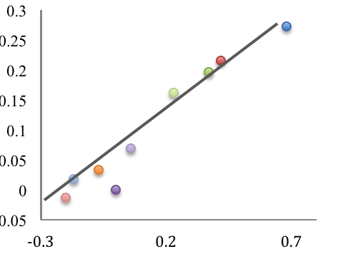

σ

log(k/ko)

*m*-CN

*m*-CF3

*m*-Cl

*p*-Cl

*p*-F

*m*-Me

*p*-CH3

*p*-tBu

H

8. (10 points) For the following examples, circle the compound which is more acidic. Please provide an explanation for each choice.

Which is more acidic? Explanation



9. (7 points) Draw a mechanism of the following reaction, which is catalytic in NaCN, showing all arrow pushing.

10. (9 points) Draw the protonation states for the following molecules at each corresponding pH.

|  |  |  |  |
| --- | --- | --- | --- |
|  |  |  |  |
| pH = 3 |  |  |  |
| pH = 7 |  |  |  |
| pH = 11 |  |  |  |

11. (12 points) More-O’Ferrall-Jencks plots are often applied to study the transition state of addition reactions. The transition state of the following general-acid catalyzed carbonyl addition (hydration) reaction using acetic acid has been found to have an  value of 0.46 and a NUC value of 0.44.



1. Fill in the remaining corners on the More-O’Ferrall-Jencks plot with the corresponding species and approximate the placement of the transition state, labeling this point as “T.S. 1”.



1. Show on the above plot where you would expect the transition state to move if FCH2CO2H were used, and label this new transition state “T.S. 2”.
2. How does using FCH2CO2H influence the state of protonation at the transition state? Explain your answer.
3. What is the extent of nucleophilic attack at T.S. 2? Explain why this makes sense.
4. Below is the structure of the T.S. when acetic acid is used. Draw the structure of the transition state which you found when FCH2CO2H is used, indicating an **approximate** percent protonation and percent nucleophilic attack.



12. (10 points)

1. Below a reaction coordinate diagram is shown for a reaction with acetaldehyde and methylamine. Describe what type of catalysis is found for this reaction.

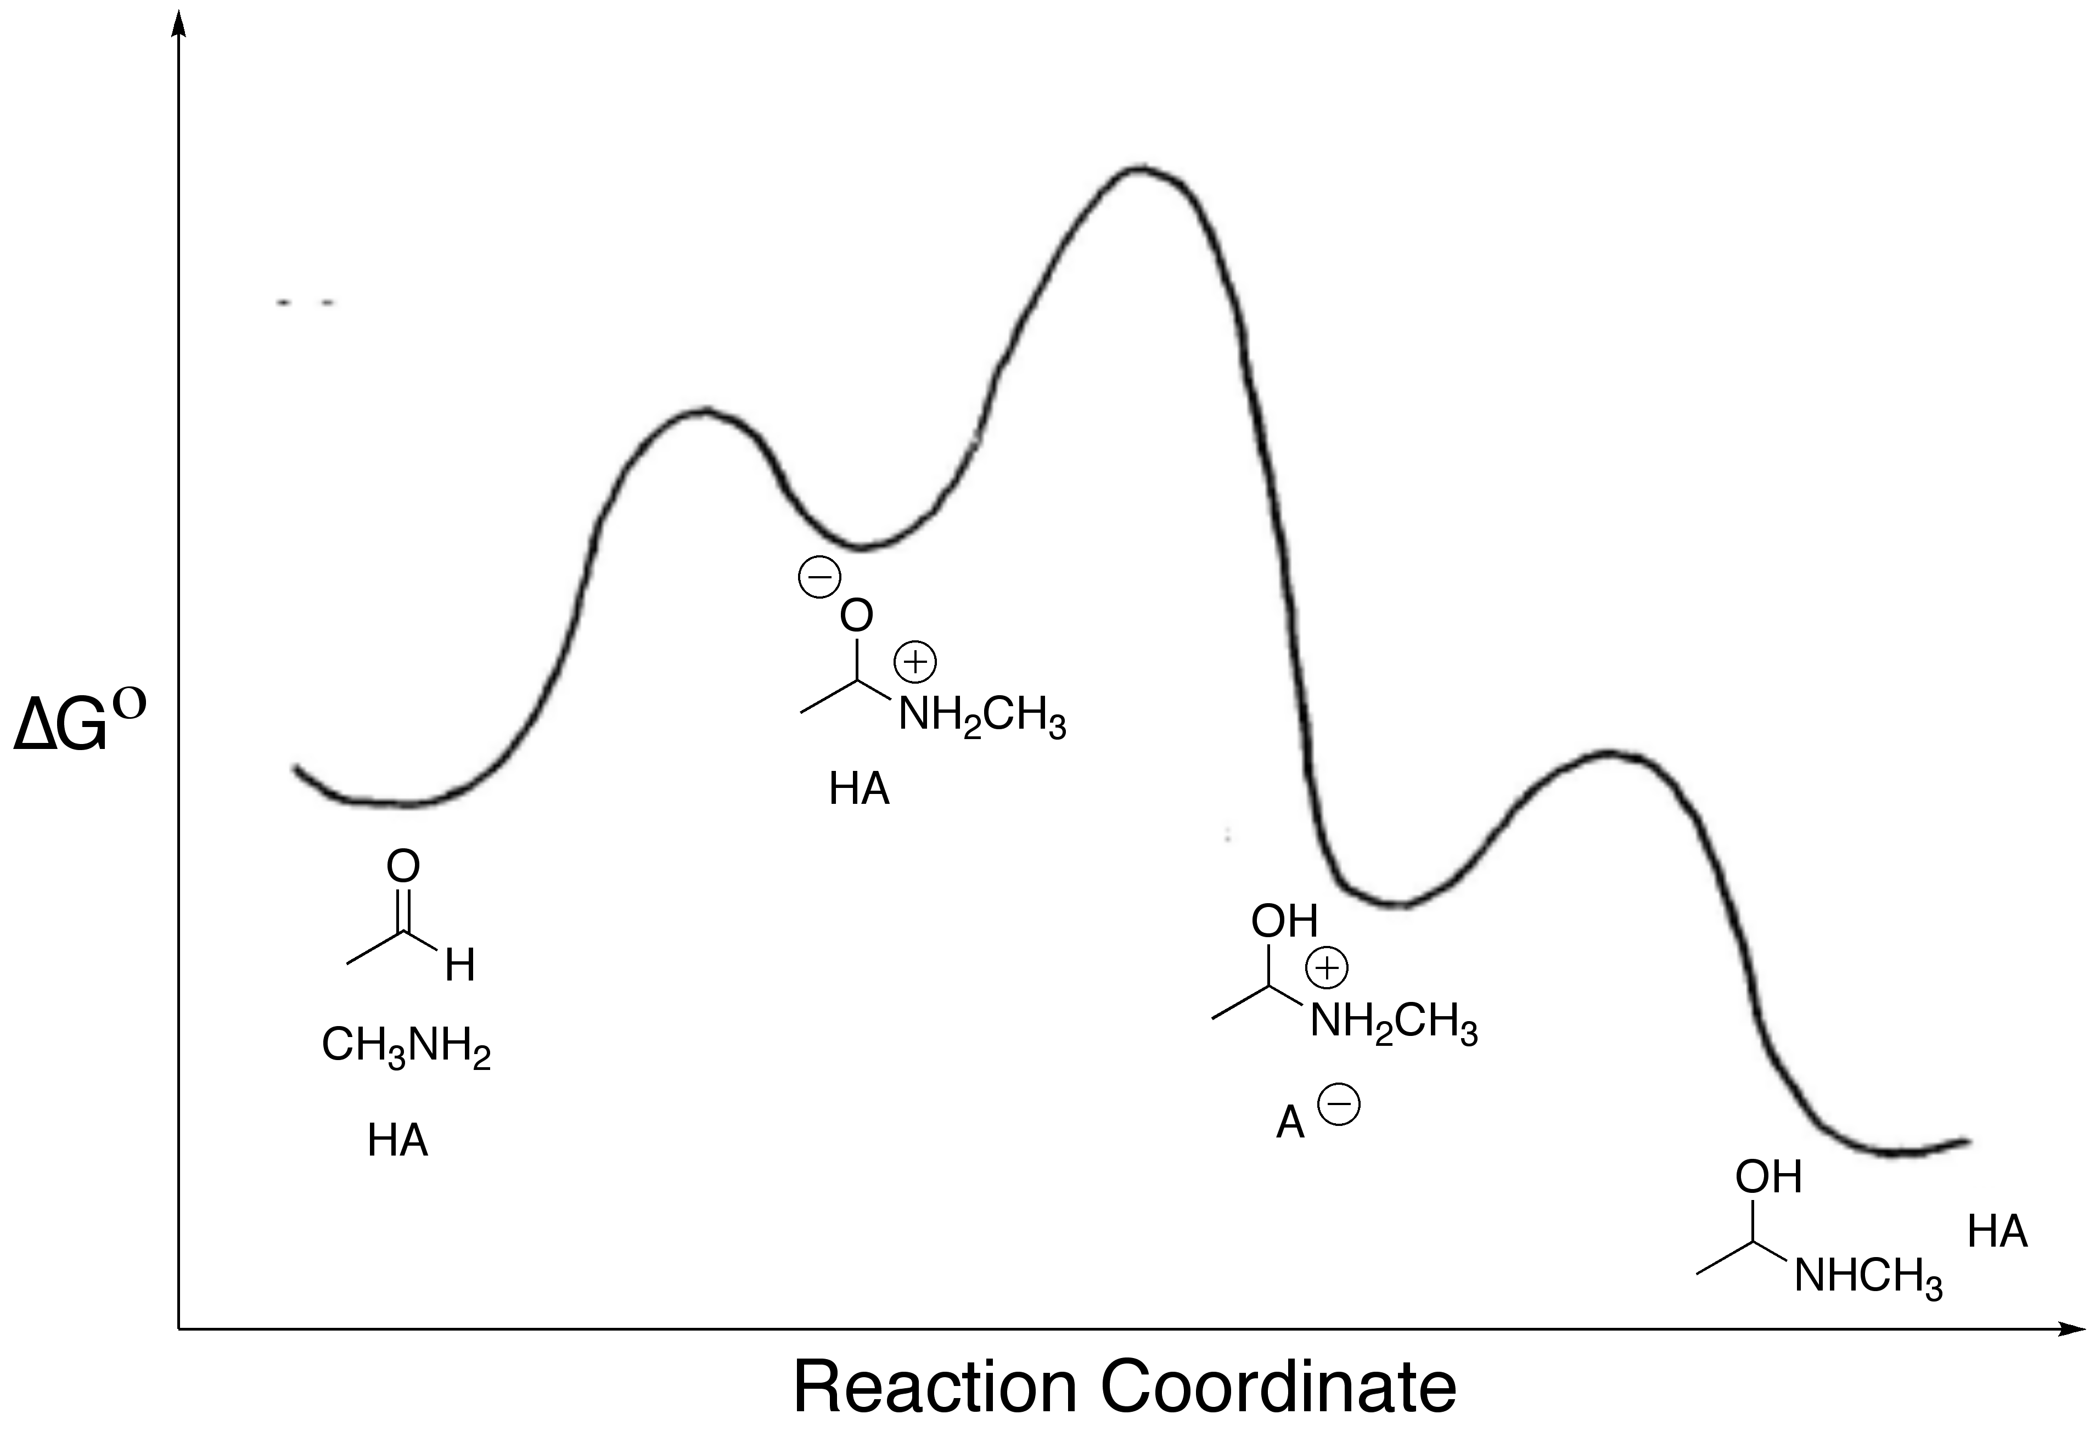

1. Fill in the two kinetic plots you would expect for the above mechanism.

[HA]

kobs

pH

Log(kobs)

1. 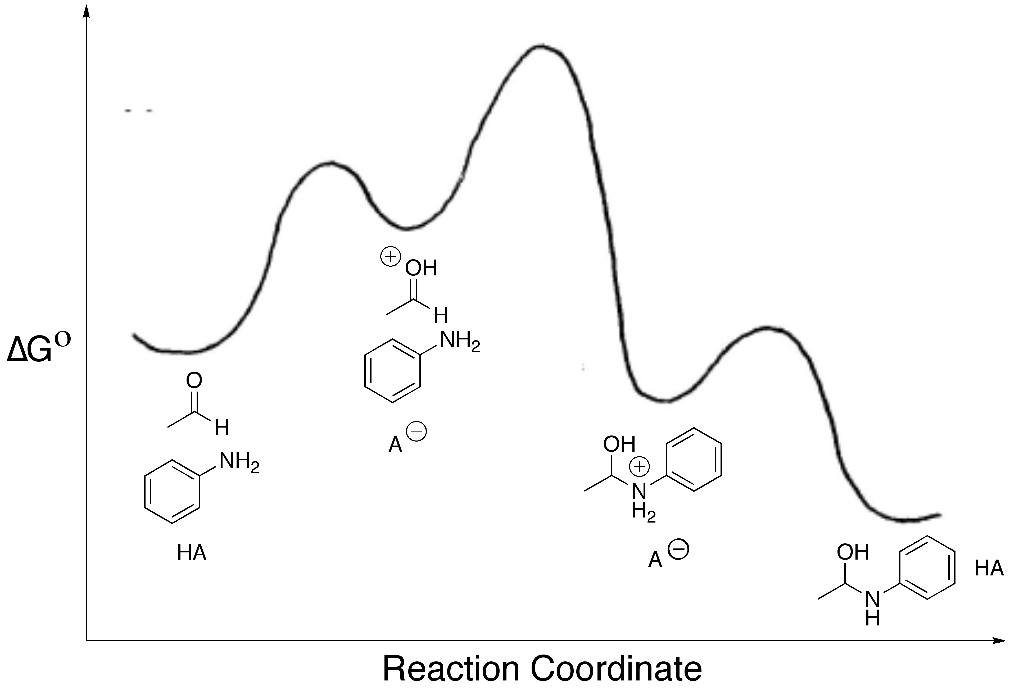Below a different reaction coordinate diagram is shown for a reaction with acetaldehyde and aniline. Describe what type of catalysis is found for this reaction.
2. Fill in the two kinetic plots you would expect for this mechanism.

[HA]

kobs

[pH]

Log(kobs)

1. Give a reasoning for why the mechanism of catalysis changes when aniline is added to acetaldehyde vs. when methylamine is added to acetaldehyde.

13. (6 points) The following reaction is first order in matallocyclobutane. The reaction is first order in diphenylacetylene at low concentrations, but becomes zero order in diphenylacetylene when 20 or more equivalents are used. When isobutylene is added, the rate slows down. Derive a rate law that conforms to these data.

